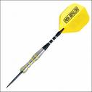
Westwood Bowl
MATCH DATE / /
5 sets of pairs, each game the best of 3 legs.
Home Team |  |  |  | Away Team
TOTAL WINS |  |  |  | TOTAL WINS
Highest Score
Highest Finish
Home Captains Signature
Away Captains Signature

